Zhu Jin Shun Kingston

**Product Photos for IPOS Pre-Created Interfaces-2nd Version**

**Includes both English and Traditional Chinese Versions**

1. **Login Page-2nd Version**

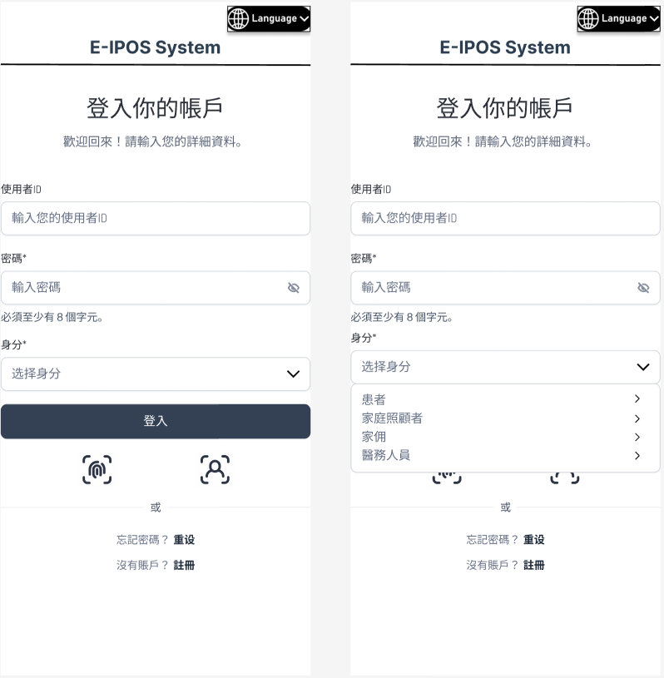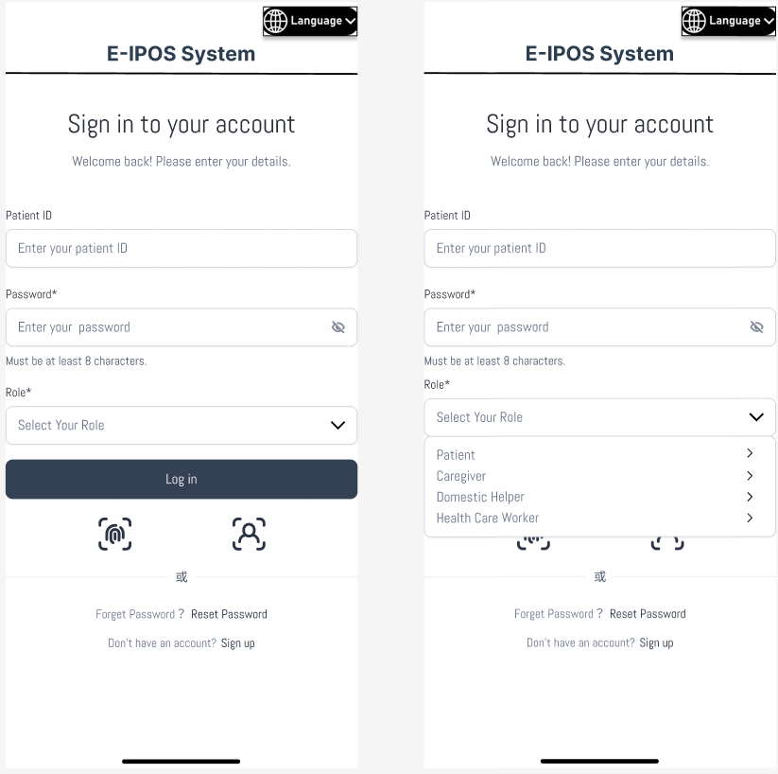

Pls change to 重**設**

Explanation:

The E-IPOS System login interface allows users to securely access their accounts by entering their patient ID and password, with options for language selection ,role selection and account registration. Fingerprint and Face ID log in is also allowed

1. **Home Page**

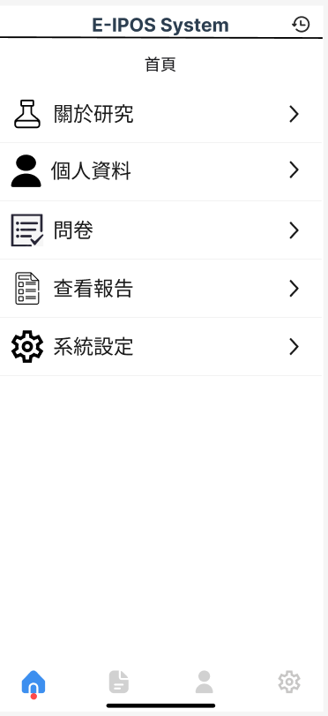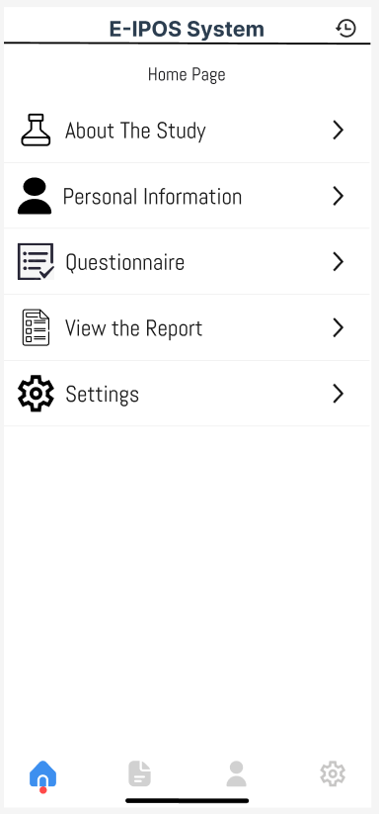

Explanation:

This home page of the E-IPOS System allows users to select functions from the home page and will redirect them accordingly.

1. **Questionnaire Selection Page-2nd Version**

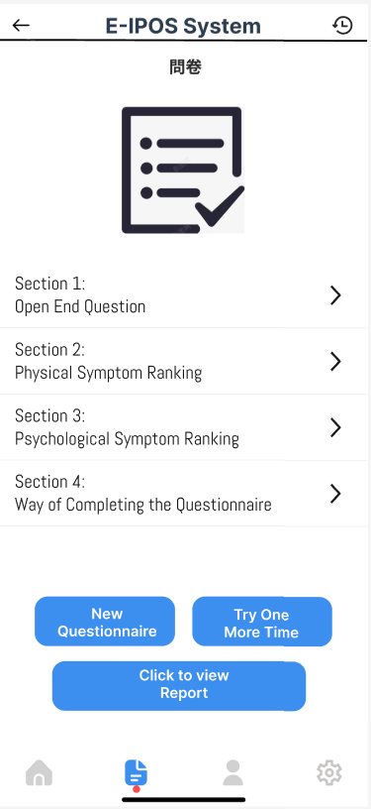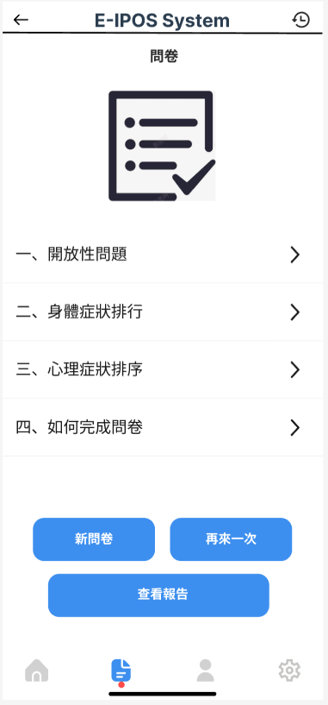

**should we align the translation of “Ranking” ?**

**排序only ?**

Explanation:

The Questionnaire page offers two primary functions:

1. Questionnaire: Users can begin a new questionnaire or retake one to assess their health status. The Patients can select different sections according to their needs to direct get to the questions.
2. Medical Report: Users can view their medical report if they have completed the questionnaire.
3. **Questionnaire Based Feedback Test**

* **Open End Questions-2nd Version**

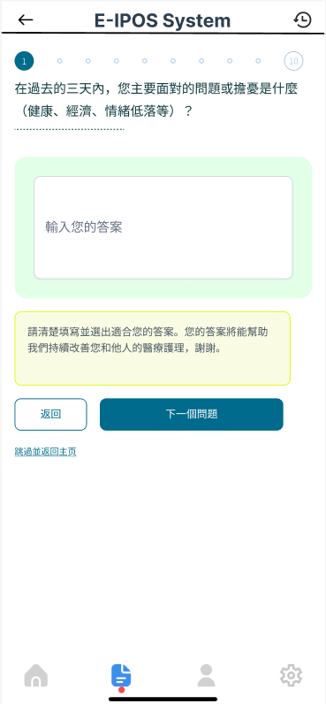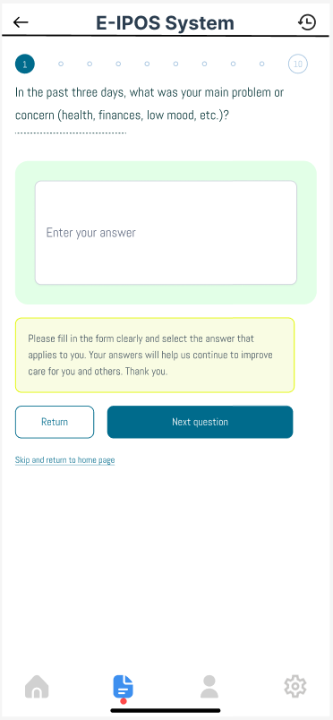

Explanation:

This page of the E-IPOS System presents a questionnaire, prompting users to describe their main problem or concern from the past three days using a open end question. Users can enter their answers, navigate to the next question, or return to the home page.

* **Ranking Questions-2nd Version**

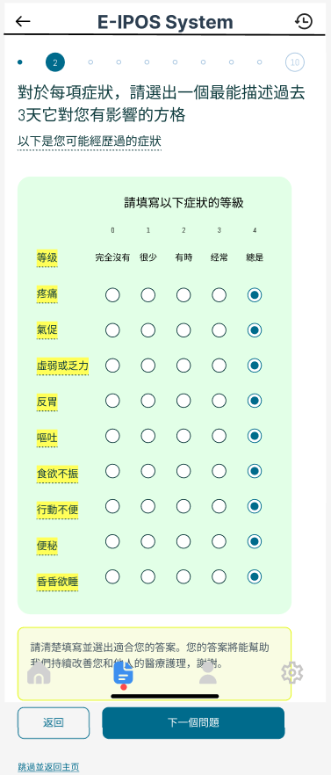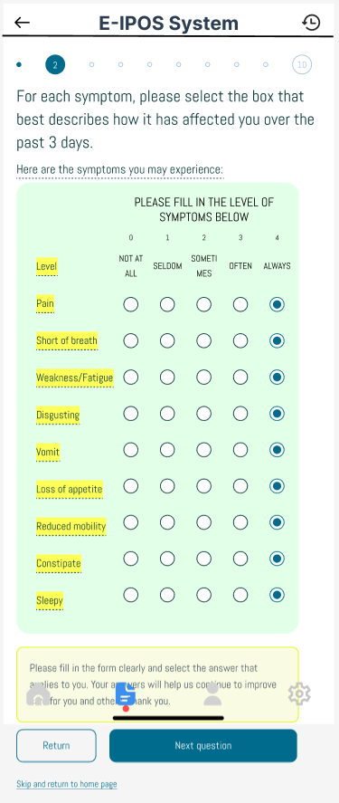

Explanation:

This page presents a questionnaire asking users to rate the impact of various symptoms experienced in the past three days through a ranking question. Users select levels for each symptom, then can proceed to the next question or return to the home page.

The picture can be scrolled down when using in phone app.

* **MC Questions-2nd Version**

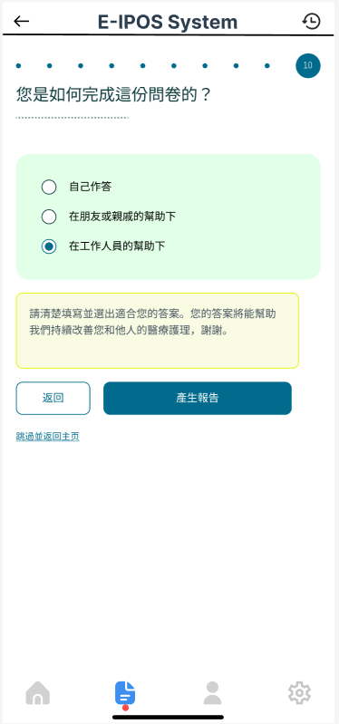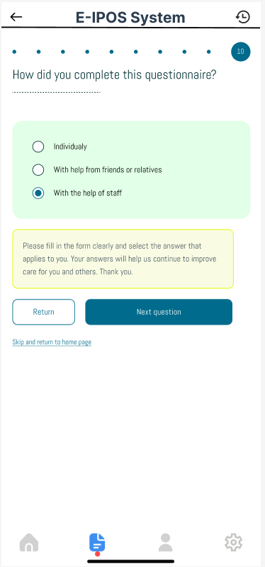

**“Generate report” instead of Next question**

Explanation:

This page asks users how they completed the questionnaire, offering options like "Individually" or "With help from staff" through a MC question. Users can select an option, return to the previous page, or proceed to the next question.

1. **Generate Result Report- 2nd Version**

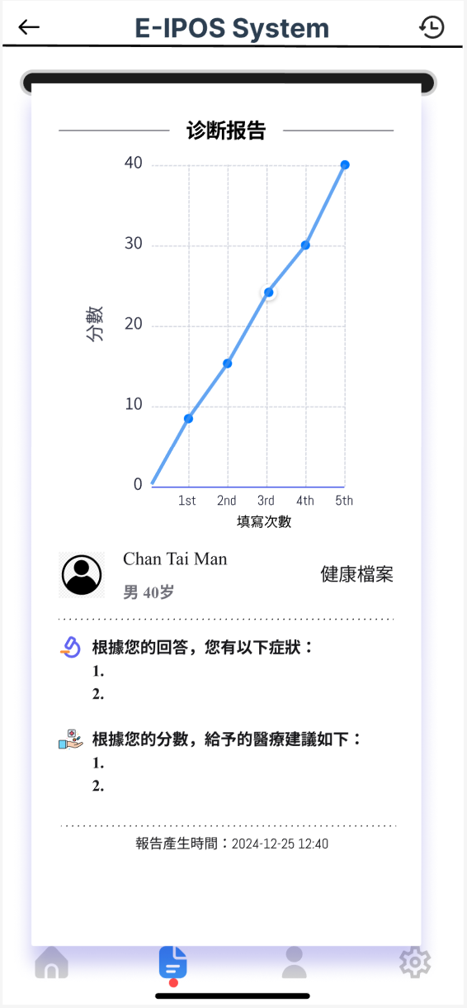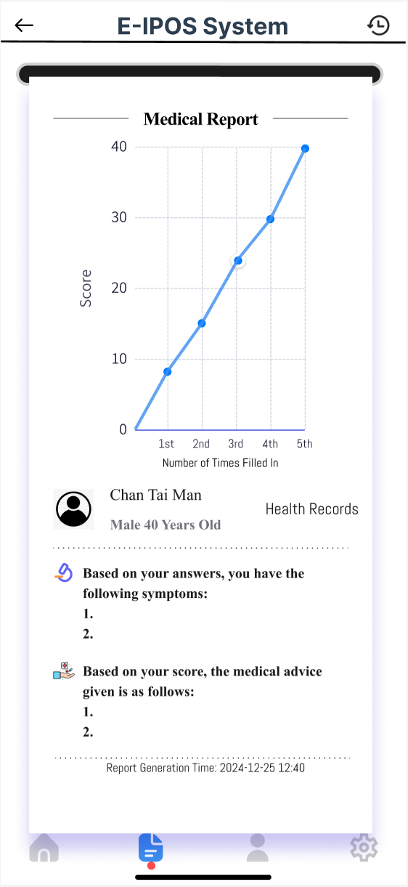

Pls change to **診斷報告**

Explanation:

This page displays reports from the E-IPOS System for the patient, presenting diagnostic and medical information. Scores are calculated based on questionnaire responses; a lower score indicates better health. Conversely, a high score indicating serious symptoms. The page also provides descriptions of potential illnesses and recommended advice for the patient based on their situation.

The patients can also see how the scores went based on their previous records.

1. **Personal Info Page**

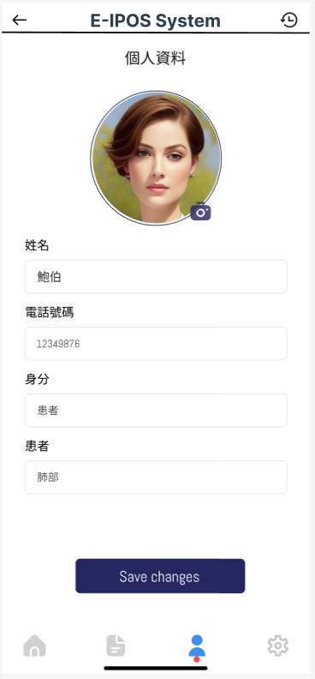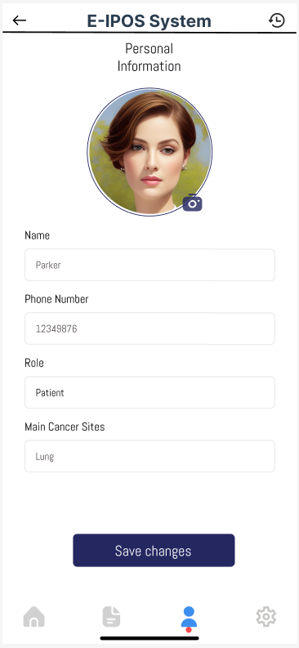

Explanation:

This is the page for the personal information of the patients which can be accessed by pressing the personal information function on the home page. This page includes name, phone number, role and main cancer sites of the patient. Changes can be made by users for their reference.

1. **Setting Page**

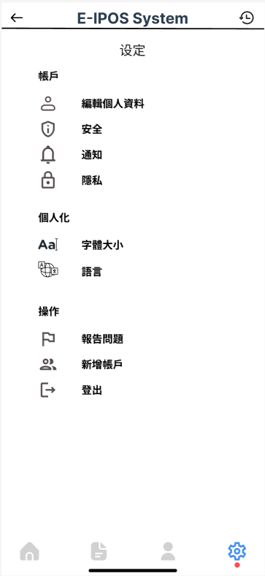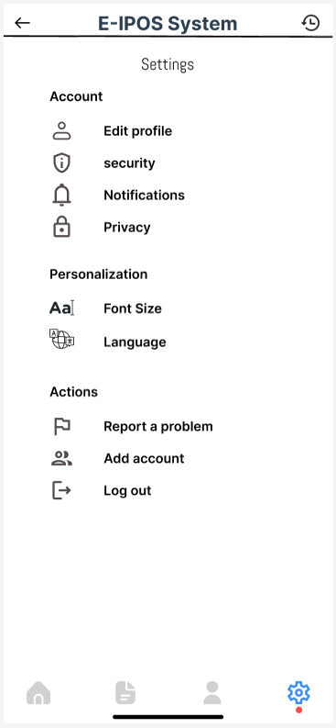

capital letter “**S**ecurity”

Pls change to 私**隱政策**

Pls change to**設**定

Explanation:

This page is the setting page for the app. Users can change different info or check any information on this page. They can also log out or change an account for their reference.

1. **Health Carer Interface for Workers**

* **Mobile App Version-2nd Version**

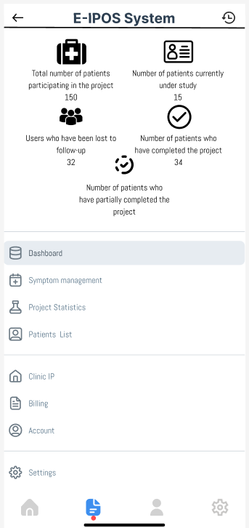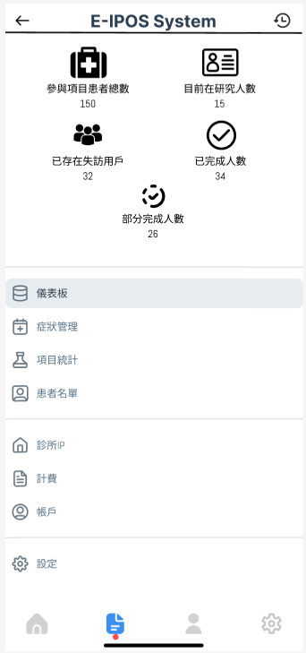

Explanation:

This page is an example page of the app version for the E-IPOS System that display project summary and statistics, including total participants, patients currently under study, and numbers of users lost to follow-up and those who have completed the project. Navigation options for symptom management and patient lists are also provided. These functions are for the care workers or workers at the hospital so they can see the performance of the patients on the questionnaires and contact them if serious symptoms have appeared.

* **Web Interface/iPad Page-2nd Version**

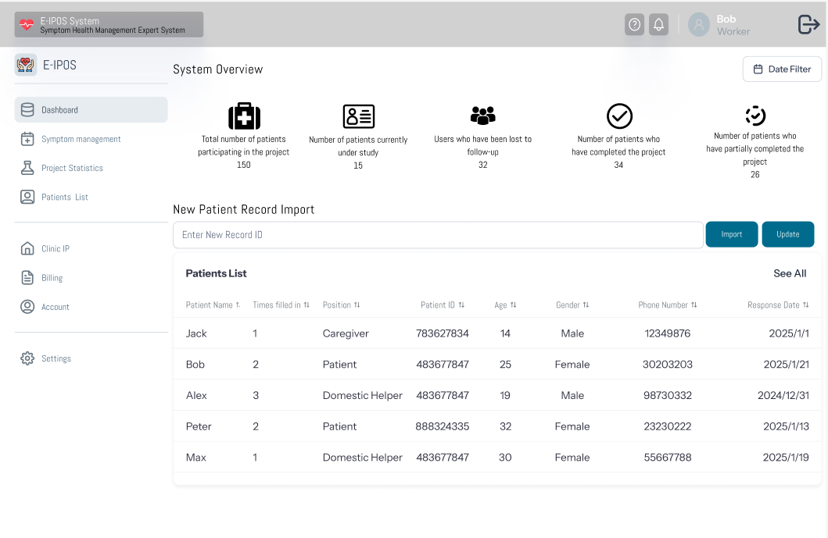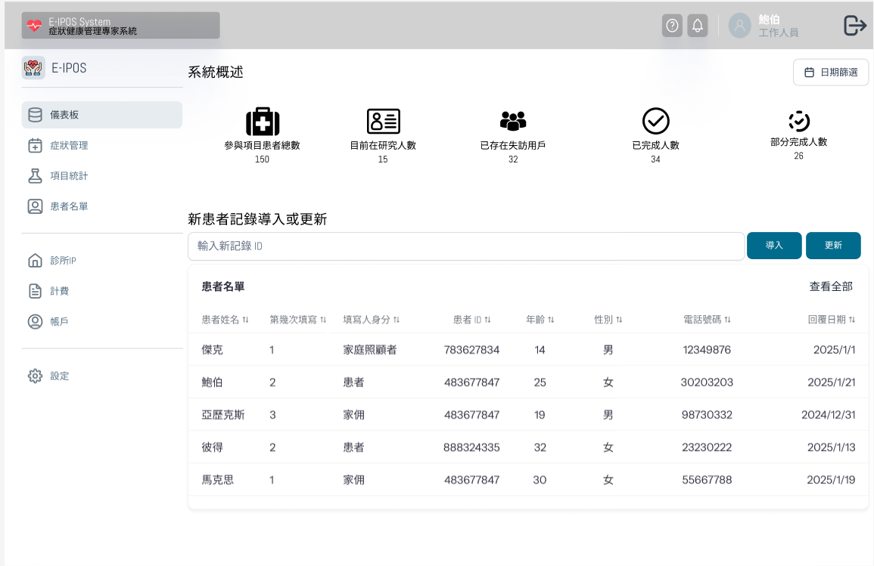

Explanation:

This page is an example page for the web interface/iPad version that displays an overview of the E-IPOS system, showcasing patient participation statistics, a list of patients with their details (ID, number of times filled in, position/role, age, gender, and response date), and options to import or update patient records for project management. These functions are for the care workers or workers at the hospital so they can see the performance of the patients on the questionnaires and contact them if serious symptoms have appeared. Users using a phone app can access this page through a link shown on the app version page or when they log in the app using an iPad.